Matthew Tran
Stack-Based Buffer Overflow Attack
The purpose of this lab is to understand how stack-based buffer overflow attacks work by disabling common system protections, analyzing stack memory, and exploiting a vulnerable program to gain a root shell.
Tools Used
- Linux terminal
- C compiler (gcc)
- GDB debugger
- Python 3 (for exploit script)
- Vim text editor
- Zsh shell
Skills Learned
- Analyzing a vulnerable C program to identify buffer overflow points
- Disabling security protections like ASLR and stack guards for controlled exploitation
- Compiling programs with specific security flags (-fno-stack-protector, -z execstack)
- Using GDB to examine stack memory layout and locate buffer/EBP addresses
- Writing and executing a Python exploit to overwrite the return address
- Gaining root shell access through a successful stack-based buffer overflow
Environment Setup)
export PS1='matthew_tran@vm:\w$ '
cd /media/sf_Lab6_
ls
Vulnerable Program Analysis)
vim stack.c
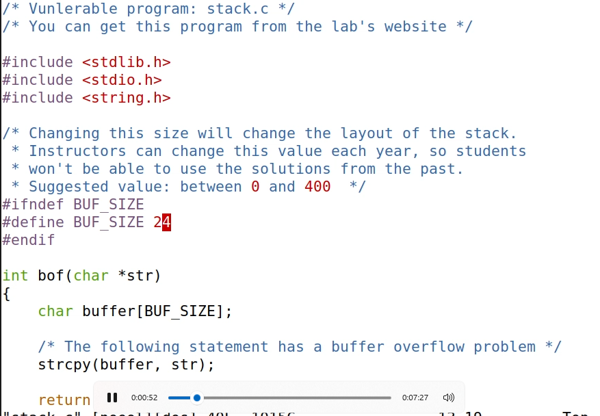
The buffer size was examined to identify a potential overflow vulnerability. The stack buffer size is 240 bytes, while the input string size is 517 bytes.
Disabling Security Countermeasures)
Disable Address Space Layout Randomization (ASLR):
sudo sysctl -w kernel.randomize_va_space=0
Address Space Layout Randomization (ASLR) was disabled to ensure consistent memory addresses during exploitation.
Set Default Shell to zsh:
sudo ln -sf /bin/zsh /bin/sh
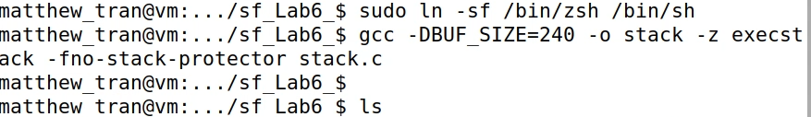
This command redirects /bin/sh to /bin/zsh, ensuring the spawned shell works as expected during the exploit.
Compiling the Vulnerable Program)
Compile stack Binary:
gcc -DBUF_SIZE=240 -o stack -z execstack -fno-stack-protector stack.c
Ls
Stack protection and non-executable stack protections were disabled to allow injected shellcode execution.
Set Root Ownership and Permissions:
sudo chown root stack
sudo chmod 4755 stack
Ls
GDB Analysis)
Compile Debug Version:
gcc -z execstack -fno-stack-protector -g -o stack_gdb stack.c
Ls
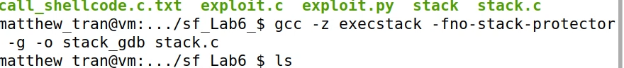
Create Required badfile:
touch badfile
Debugging with GDB:
gdb stack_gdb - launches the debugger to analyze your vulnerable program.
b bof - sets a breakpoint to pause execution at the vulnerable function.
R - runs the program until it hits that breakpoint.
x &buffer - shows the memory address where your vulnerable buffer begins.
x $ebp - shows the address of the saved base pointer, used to calculate how much to overflow.
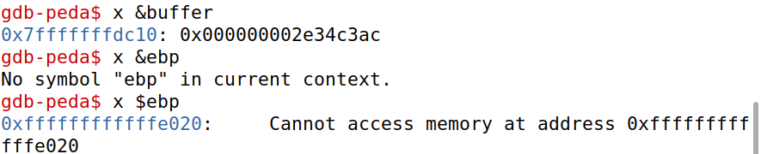
The buffer and base pointer (EBP) addresses were recorded for use in exploit construction.
Exploit Construction)
Modify exploit.py:
Within this code add the address for the buff and ebp.
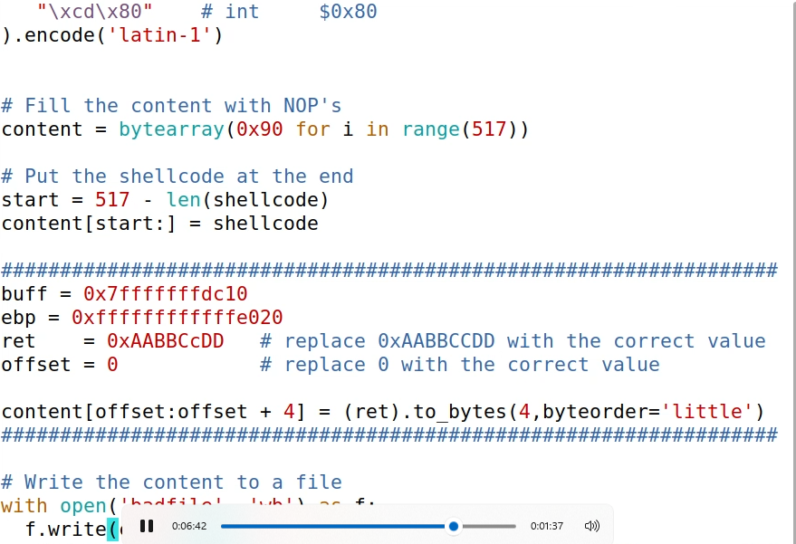
vim exploit.py
The recorded buffer and EBP addresses were inserted into the exploit code to overwrite the return address.
Generate Malicious Input:
rm badfile
python3 exploit.py
Exploit Execution and Verification:
./stack
whoami
id
Successful exploitation results in a root shell, confirmed using whoami and id commands.

